Connor and Robert

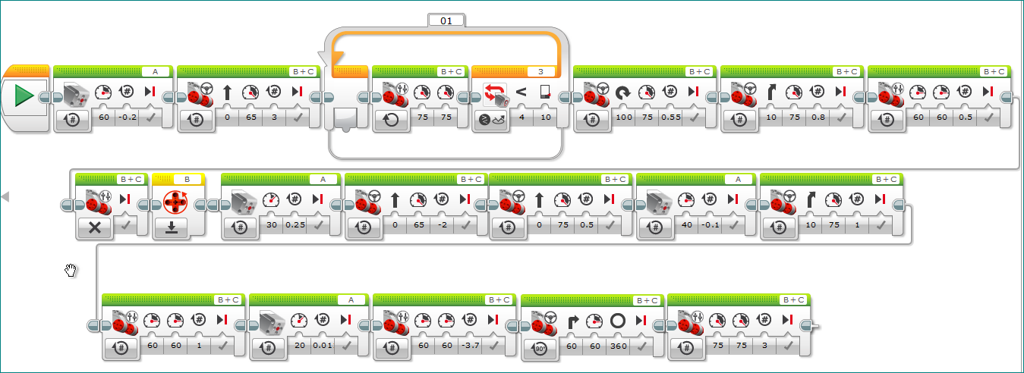

Adam and Austin

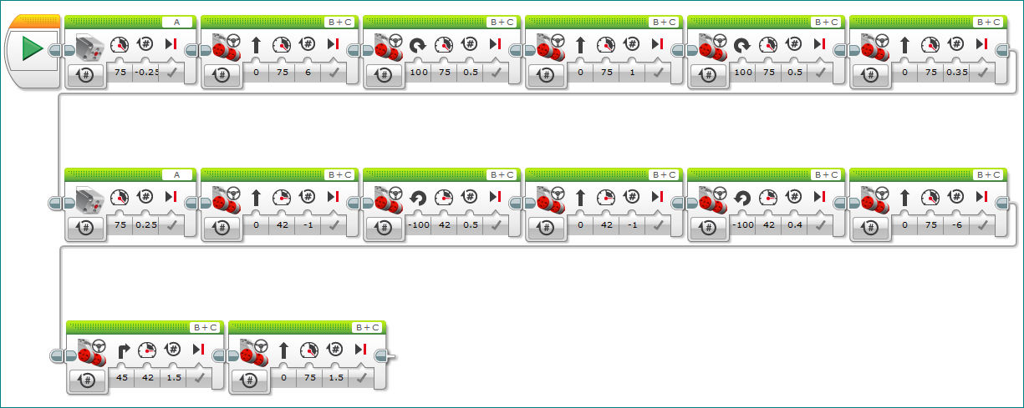

Devvin and Alex W

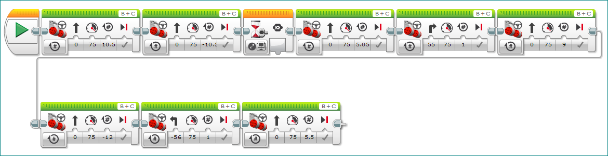

Alex J & Zach

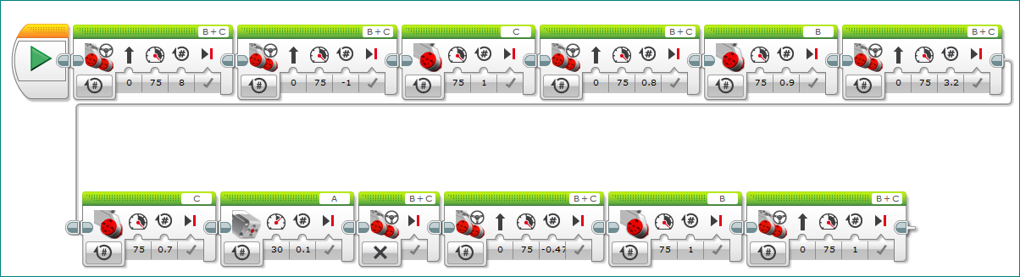

Justin and Andon

